
Kind Attention – Mr. Majd
FALCON’s Response to RFP
MSC_Q for Supply of SWEDI Sorter System Option 3(b) - Draft
May 22, 2023

M/s MSC-Qatar

Offer Ref: F22-00262_03(b); Date 22.05.2023

Subject – Techno-Commercial Offer for SWEDI Sorter Option 3(b)

Dear Team,

We are pleased to submit our Techno-Commercial Offer in response to your RFP
As you will note, we have studied your requirements in great depth and, along with the information collected during the workshops and calls with you, we have put together a detailed technical proposal laid out in various sections and sequenced to enable you to understand our proposed solution and to re-enforce our commitment to be your partner in this strategic initiative.
In subsequent sections, we have highlighted the capabilities and experiences of Falcon Autotech with sections on our Automation Technologies and references.
To conclude, I would like to add my personal commitment, on behalf of Falcon Autotech. As we move through the RFP process, please do not hesitate to contact me and my team. We will be pleased to assist you for any further information or clarifications that you might have.
tails
Contact Person : Umer Saleem
Title : Regional Head – Middle East
Mobile : +971 (0) 507198540
Email : umer.saleem@falconatuoonline.com
Company Details
Company Name : Falcon Autotech Pvt. Ltd.
Regd. Office : 57, Nimri Colony, Double Storey Flats, Delhi – 110052
Website : www.falconautotech.com

Response to RFP for SWEDI Sorter_ MSC_Qatar_Option 3(b)

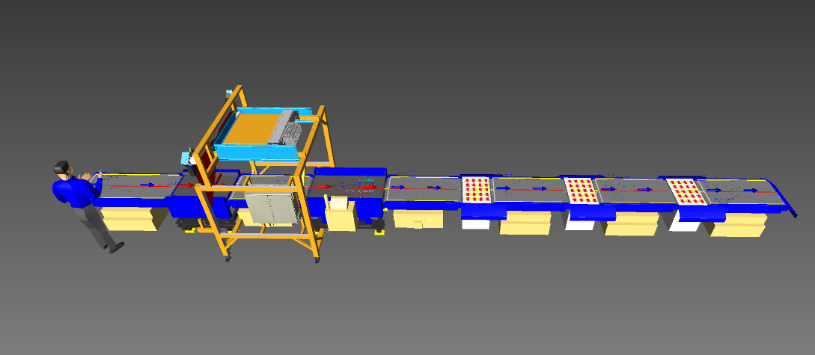

Proposal Reference – F23-00262-03(b)

Falcon Autotech Private Limited
Plot No 308 & 309
Ecotech-1 Extension, Greater Noida
Uttar Pradesh- 201308
India.

Umer Saleem
Regional Head – Middle East
+971 (0) 507198540
umer.saleem@falconautoonine.com

Table of Contents
1. Glossary 6
2. About Falcon 7
3. Falcon’s Experience and Achievements in Sortation Space Globally 19
4. Reference projects 20
4.1 Project 1- (CEP Client, UK) 20
4.2 Project 2- (CEP Client, Riyadh) 21
4.3 Project 6- (Client – Courier Express Parcel, Dubai & Jeddah) 22
4.4 Project 4- (CEP Client, Sydney) 23
4.5 Project 3- (Client – E-Commerce, India) 24
4.6 Project 5- (Ecommerce Client, India) 25
4.7 Project 7- (E-commerce, India) 26
5. Handled Parcel Spectrumions Minimum Maximum 27
5.1 Product size Conveyable on the entire system. 27
5.2 Parcels/Totes to be loaded on Conveyor/Sorter shall have the following characteristics: 27
5.3 Parcel not loadable on the system 28
5.4 Types of Products 28
6. Proposed System Description 29
6.1 Objective 29
6.2 Summary of the System 29
6.3 Main benefits of the proposed solution 30
7. Layout View 30
8. Proposed System Capacity 31
8.1 System Capacity 31
9. System description 31
9.1 Loading conveyor and Buffer 31
9.2 Scanning & Weighing 32
9.3 Outbound Sorting 33
10. System Components 34
10.1 PVC Belt Conveyor 34
10.2 Swivel Wheel Sorting Unit - Falcon 36
10.3 Top side Barcode Scanners with Volume Measurement System 37
10.4 Buffer Conveyor 37
11. Proposed System Technical Details/BOM 38
11.1 Mechanical Equipment 38
11.2 Electrical Equipment 38
11.3 Control System 38
12. Falcon’s WCS CONTROLIT 39
13. Key Component Makes 40
14. Safety 41
14.1 Push Buttons 41
14.2 Program Management 41
15. Commercial Terms 42
15.1 Price Sheet 42
15.2 Payment Terms 43
15.3 Delivery time line 43
16. Warranty Period 43
17. Exclusions 44

Glossary
S. No. | Term | Description
1 | RFP | Request For Proposal
2 | PPH | Parcels Per Hour
3 | DBO | Damaged Barcode
4 | MEZZ | Mezzanine
5 | AC | Alternating Current
6 | DC | Direct Current
7 | PLC | Programmable Logic Controller
8 | IT | Information Technology
9 | BOQ | Bill Of Quantity
10 | I/O | Input/ Output
11 | PDP | Power Distribution Panel
12 | PC | Personal Computer
13 | UPS | Uninterrupted Power Supply
14 | SWEDI | Swivel Wheel Divert

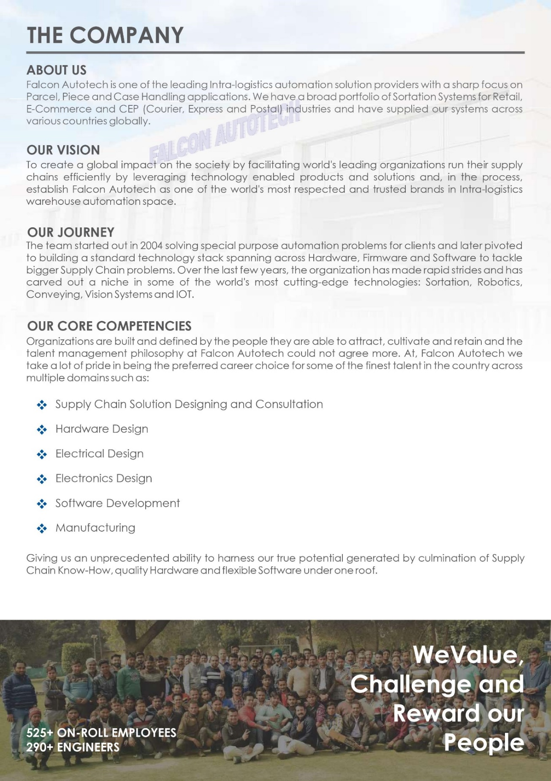
About Falcon
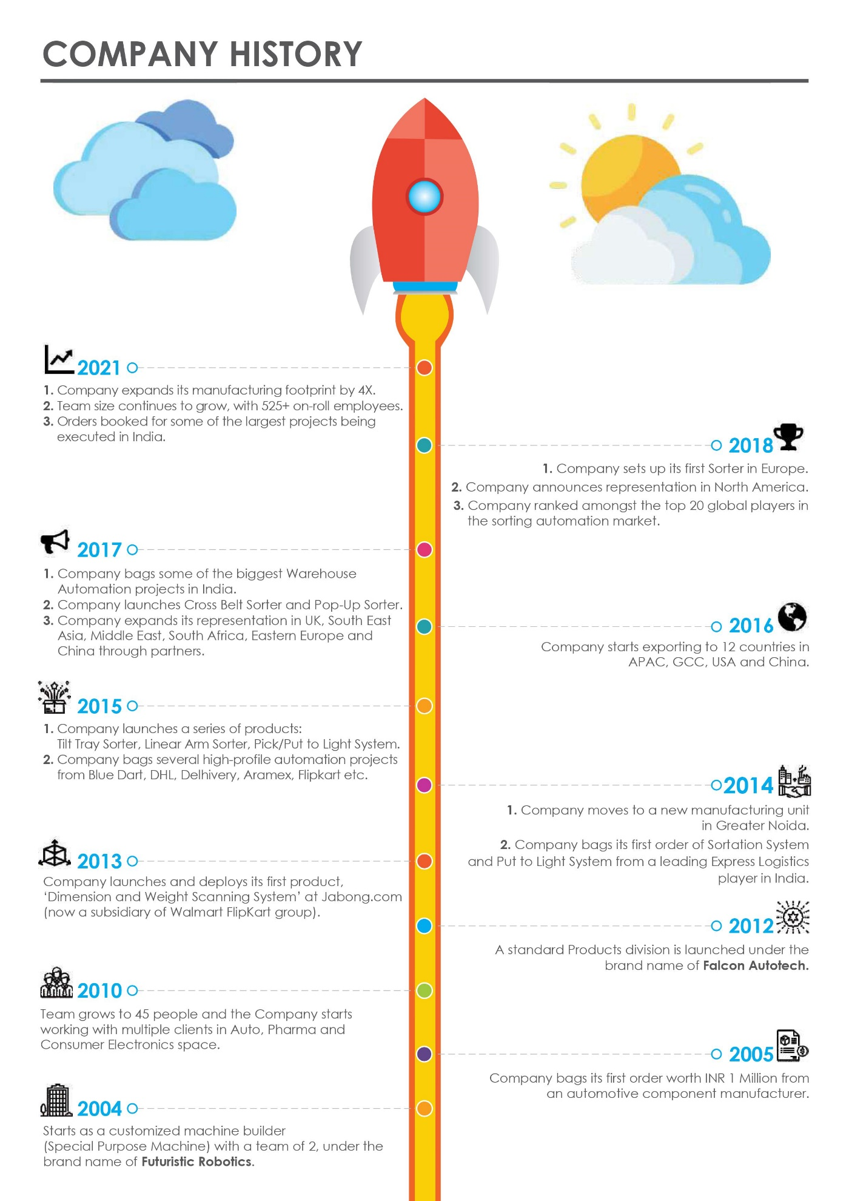
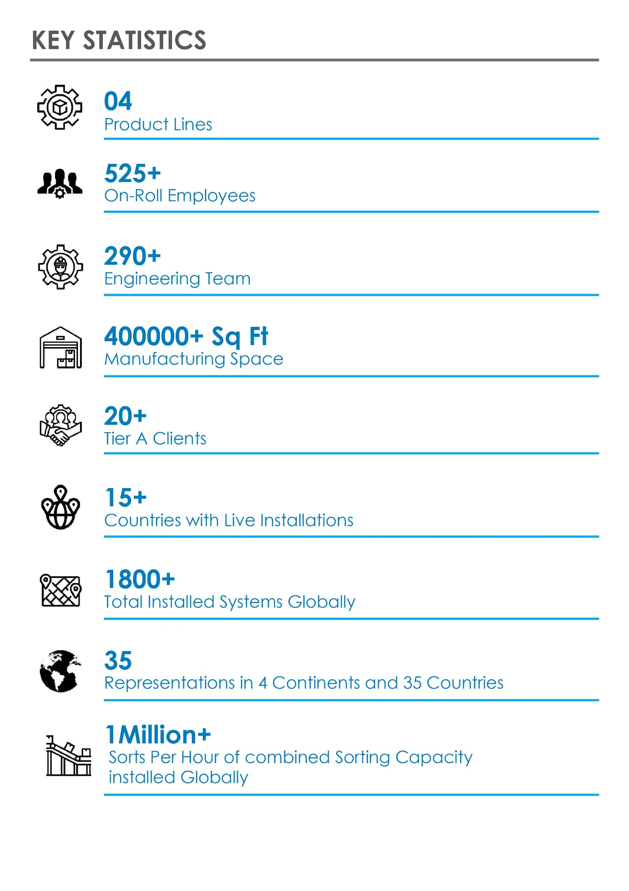
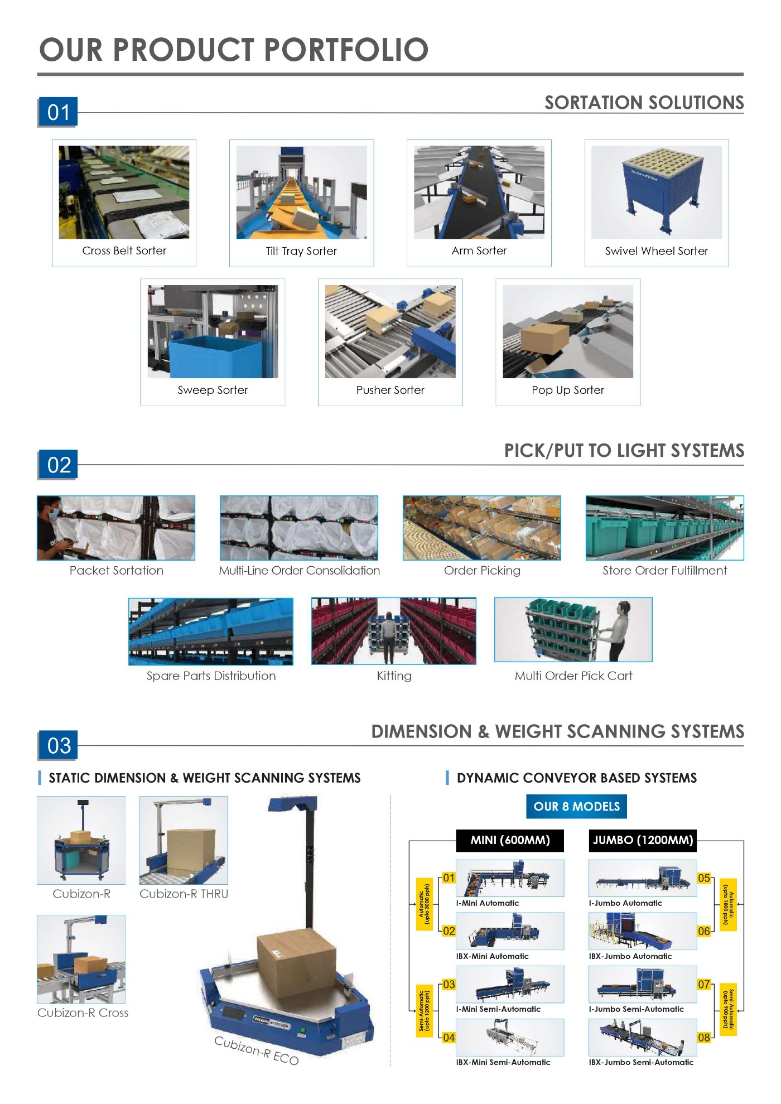
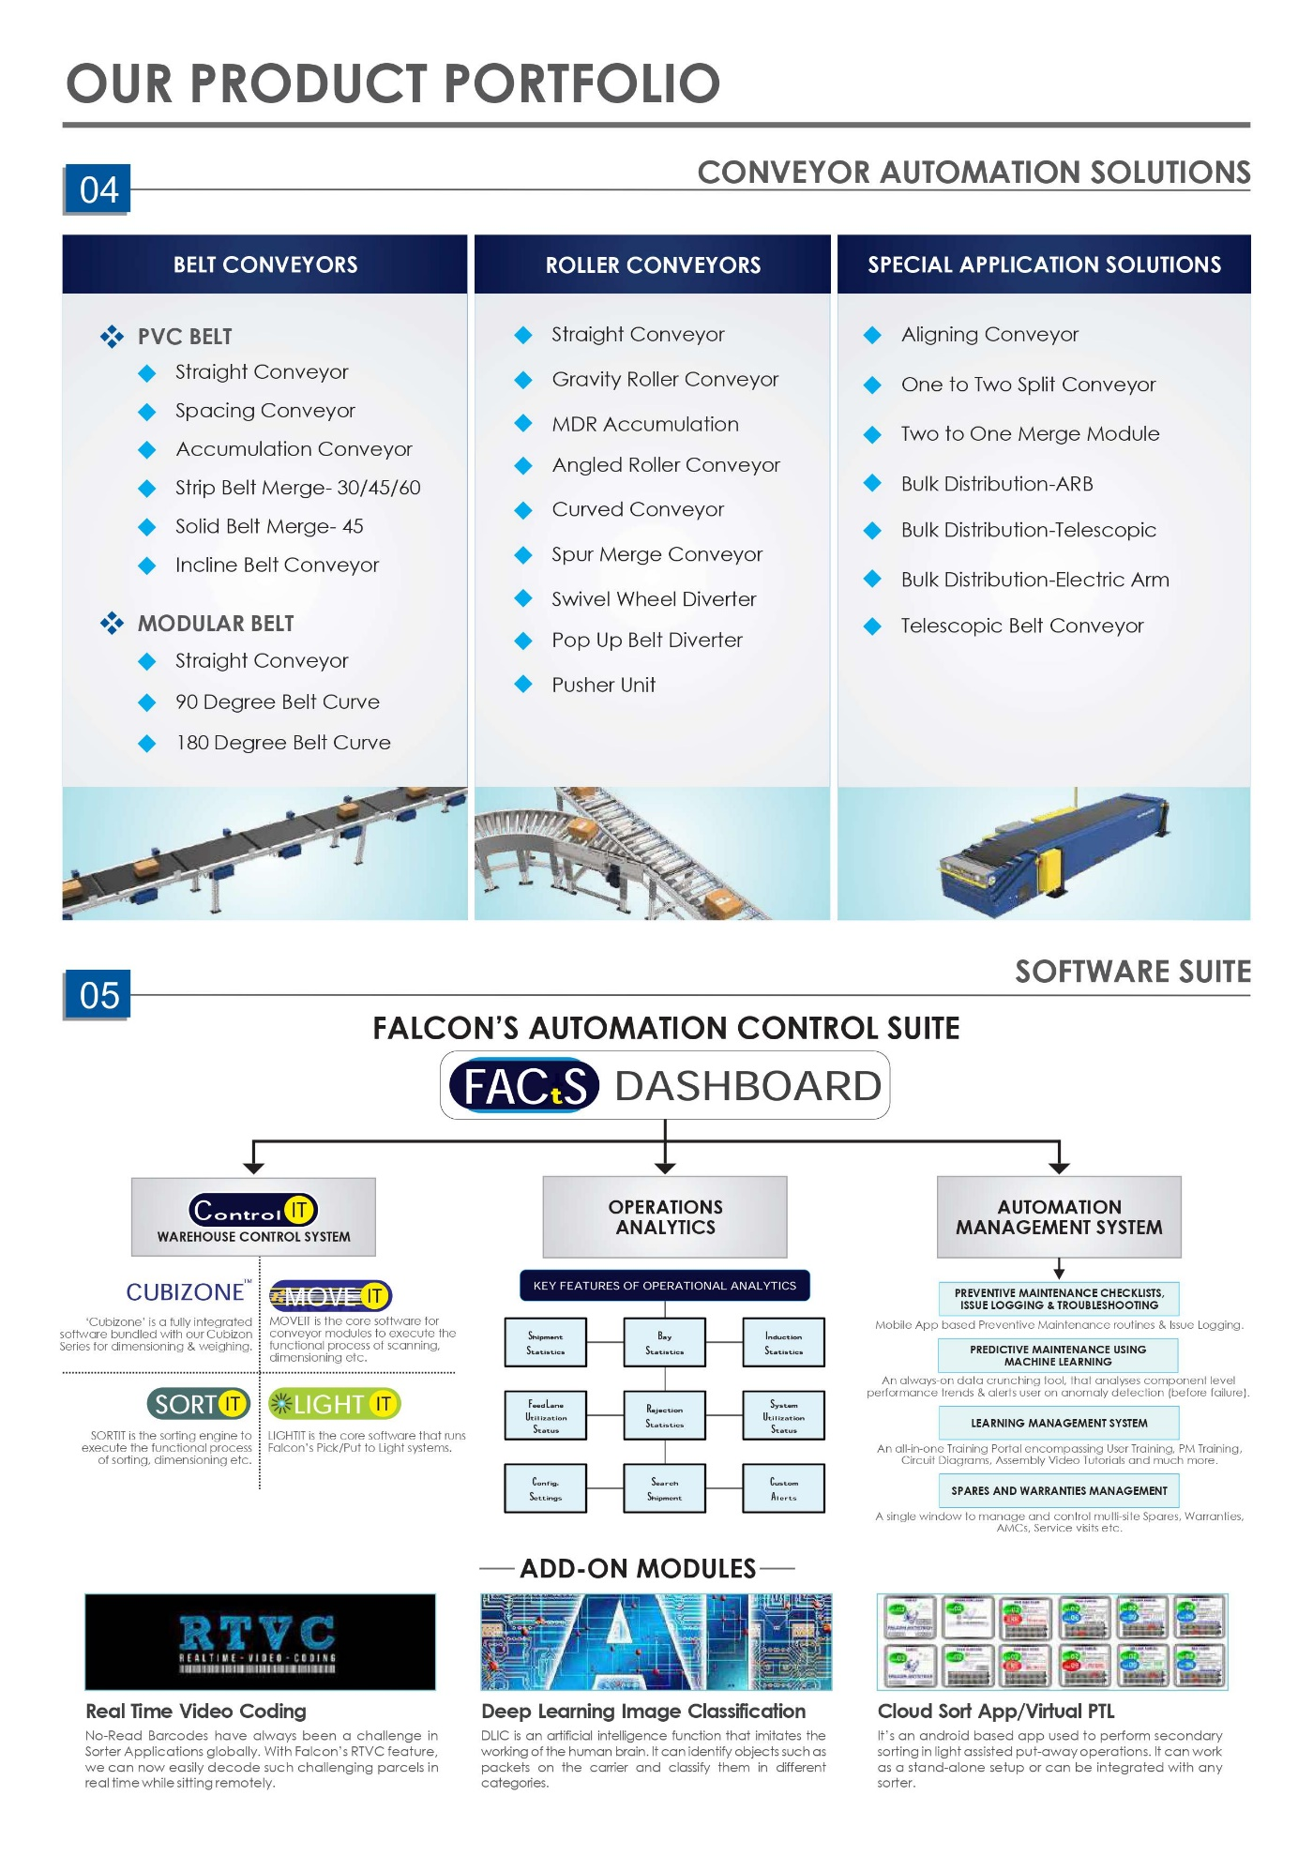
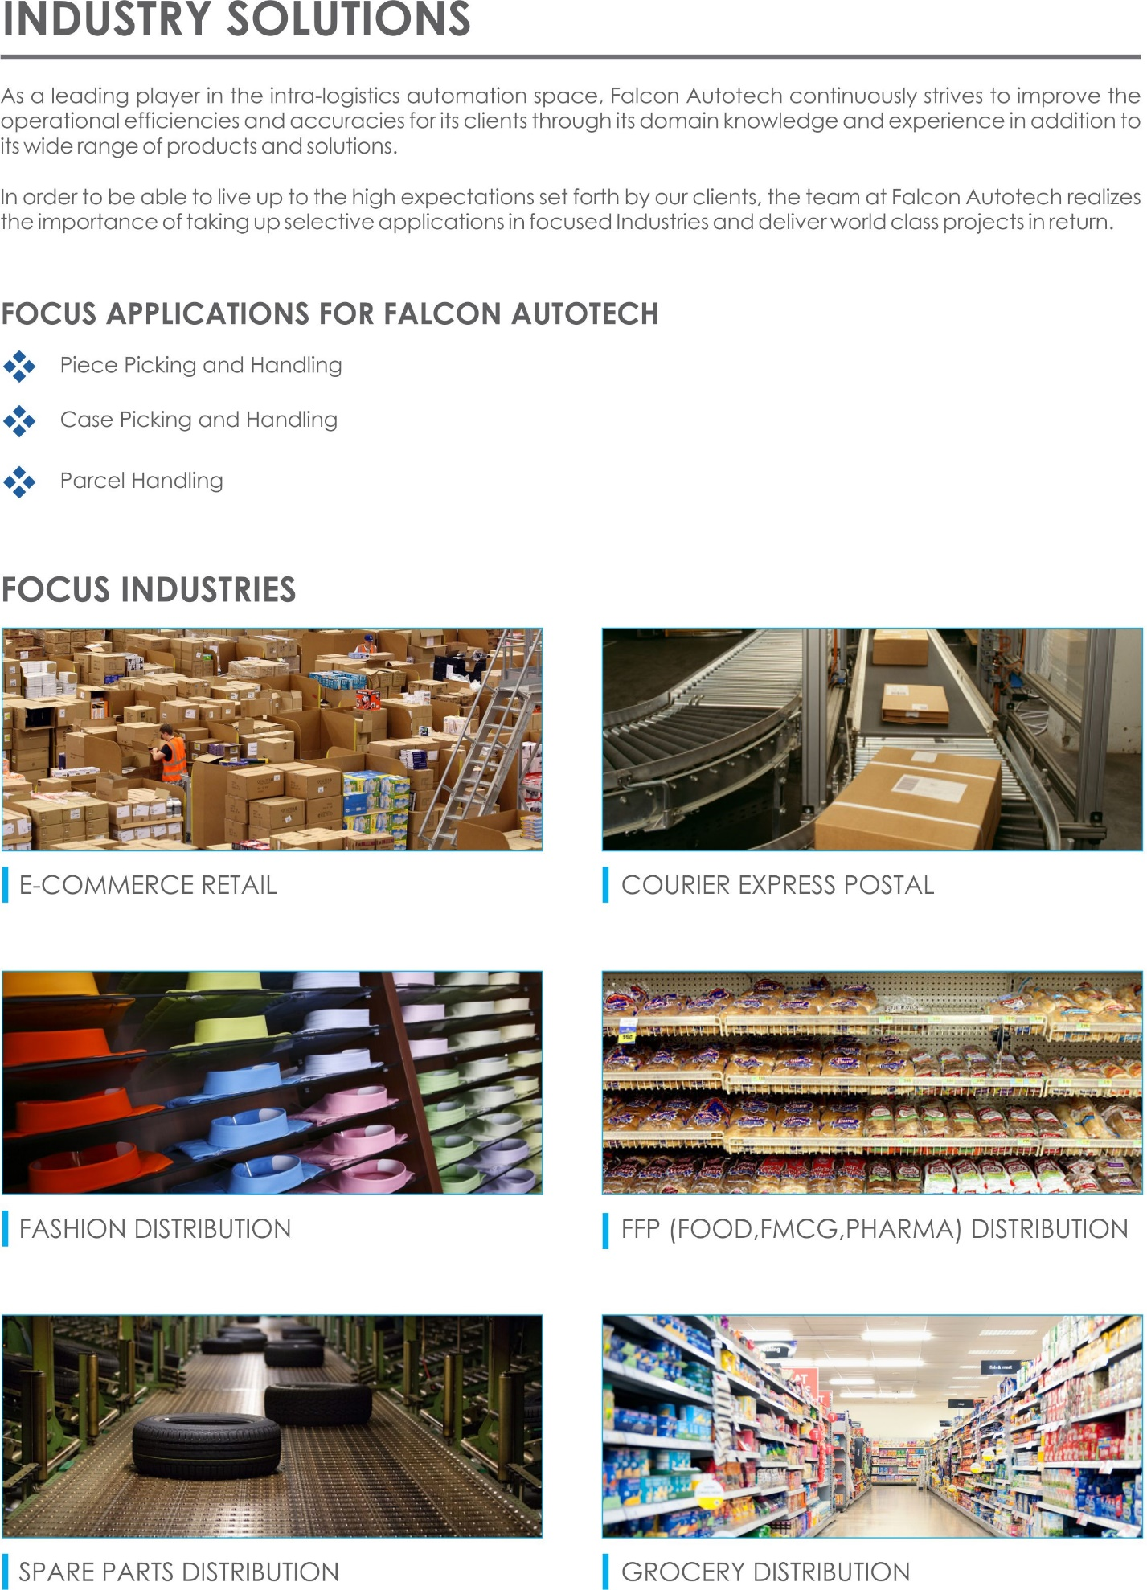
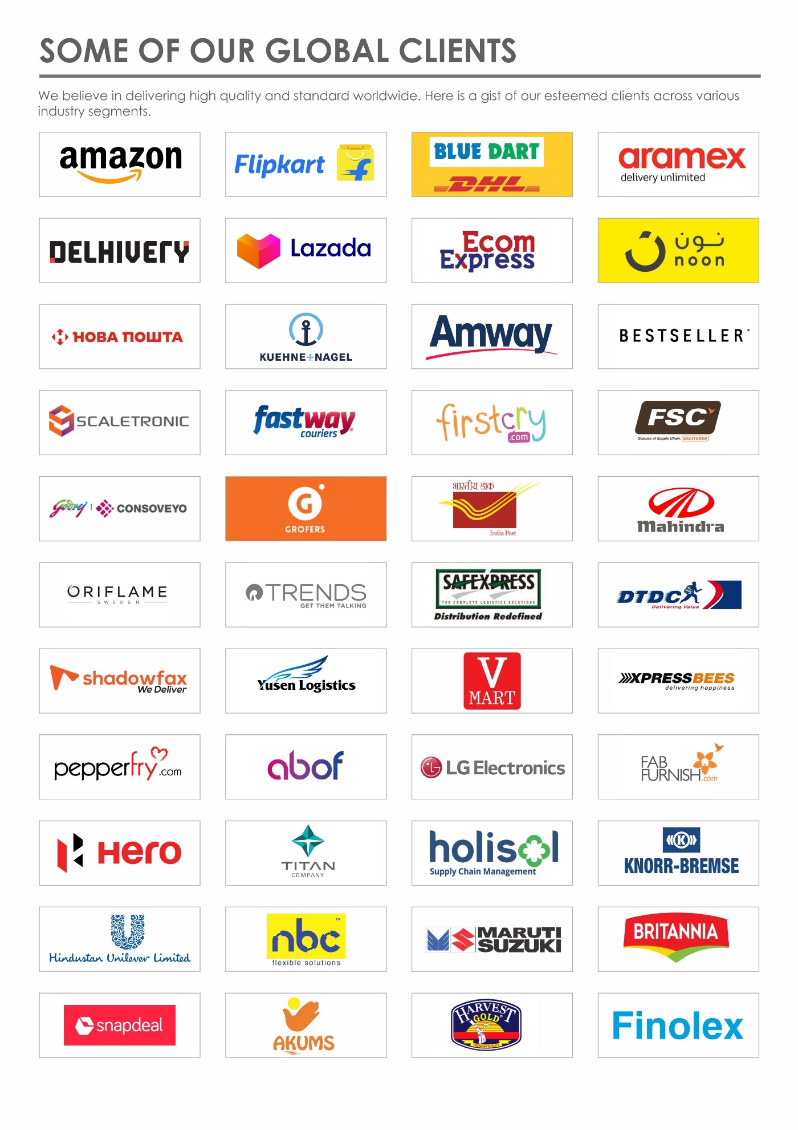



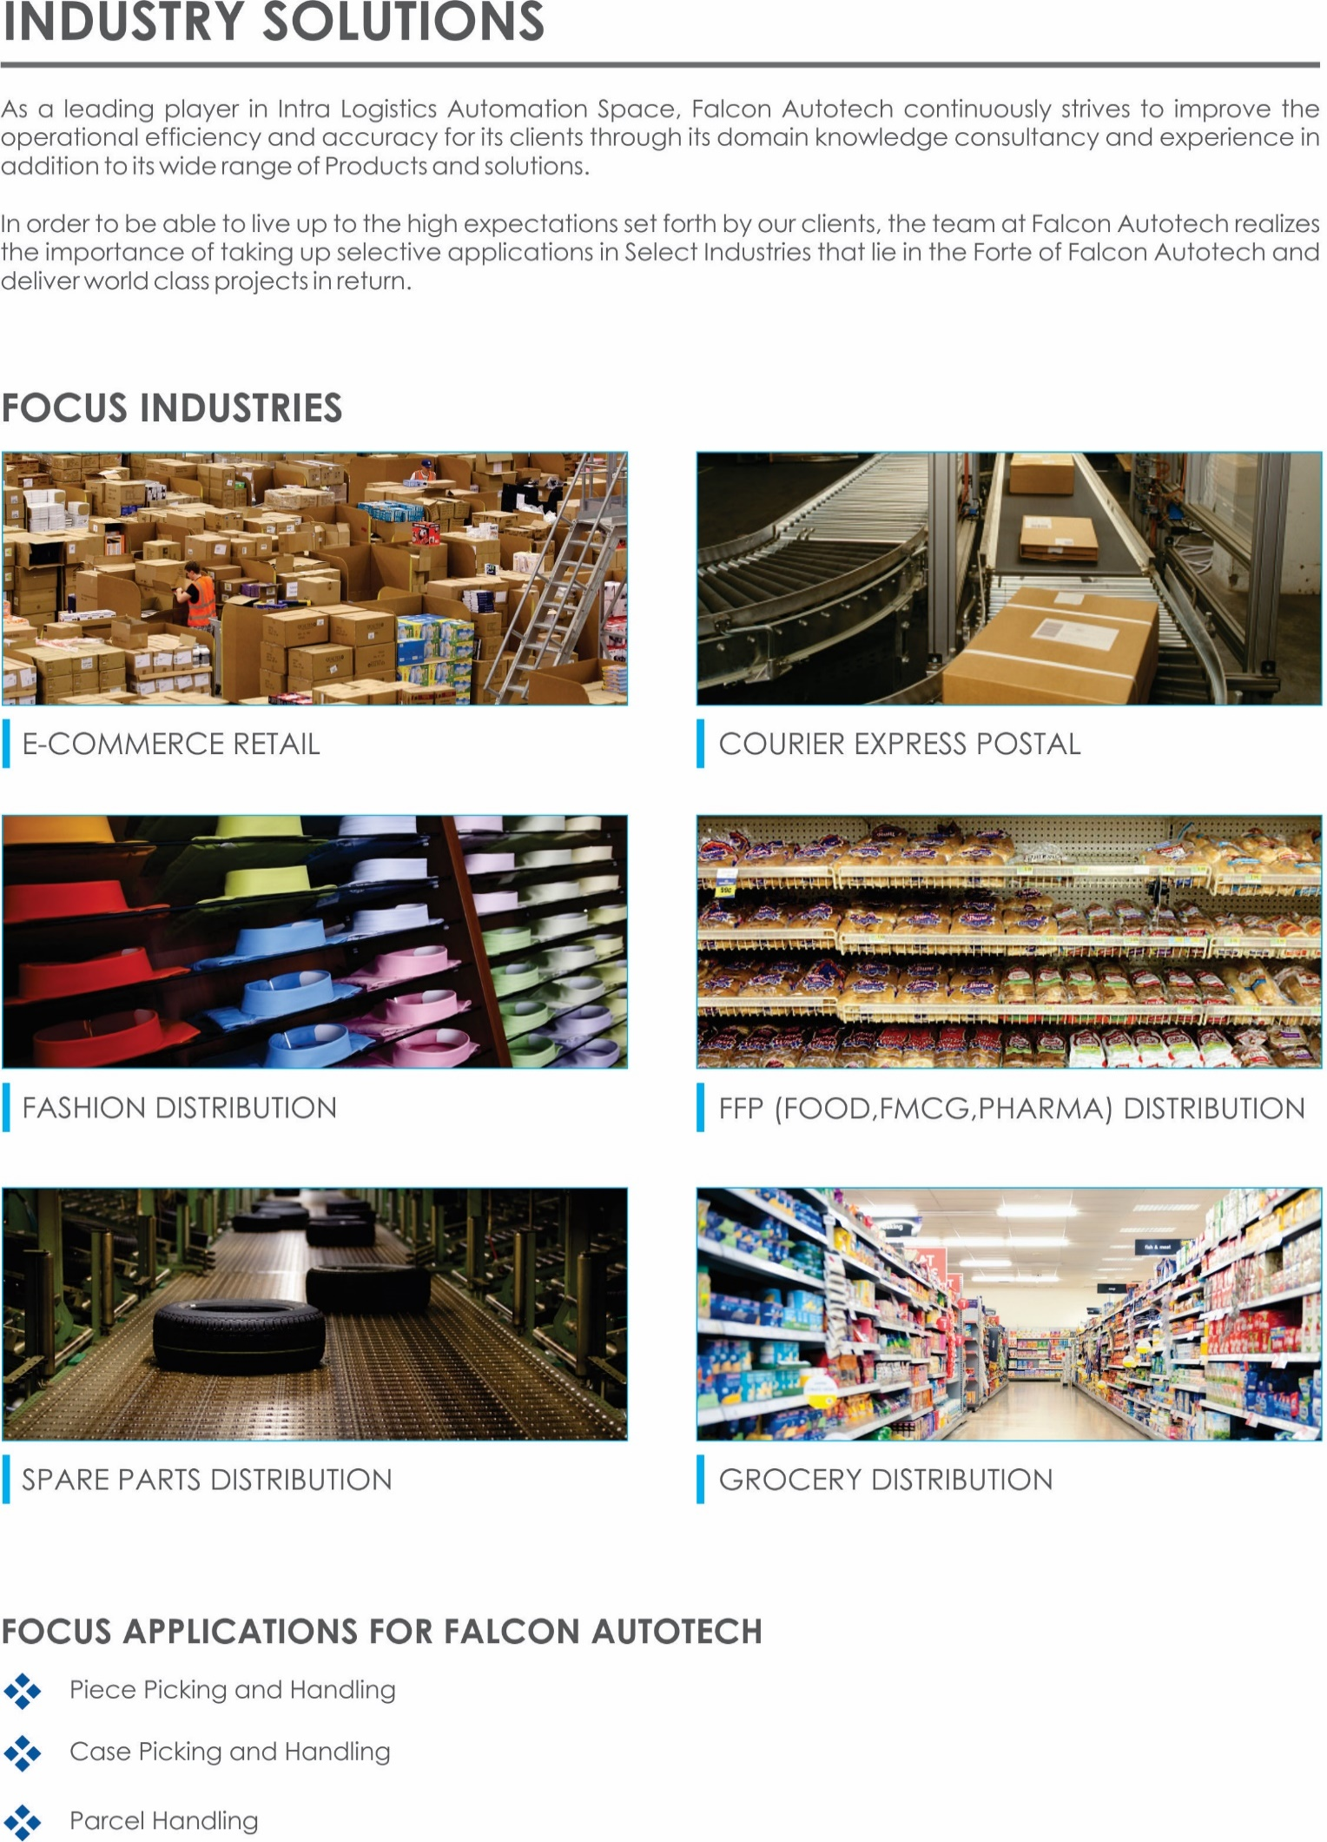

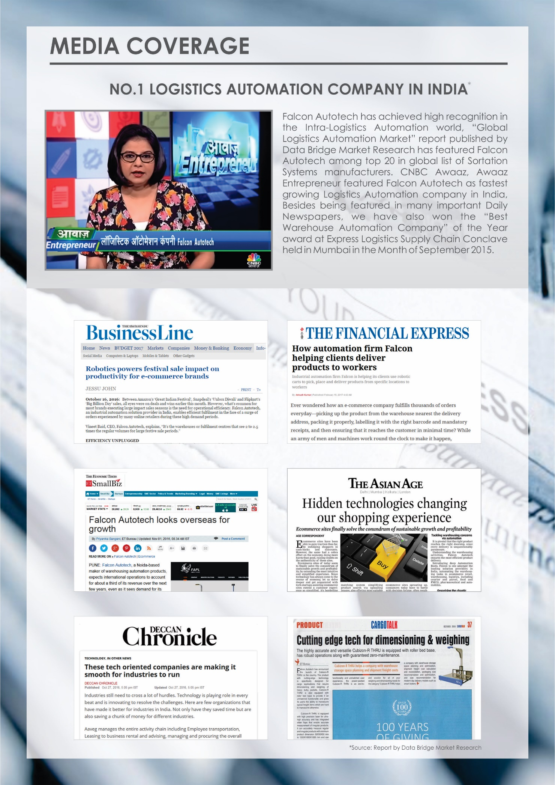



Falcon’s Experience and Achievements in Sortation Space Globally
- Ranked among Top 20 Sortation System Suppliers globally. Only company from APAC/EMEA Region.
- Currently possess one of the World’s largest portfolio in Sortation Technologies: 7 In-house technologies.
- Total installed capacity of 6 Million Parcels per day worldwide.
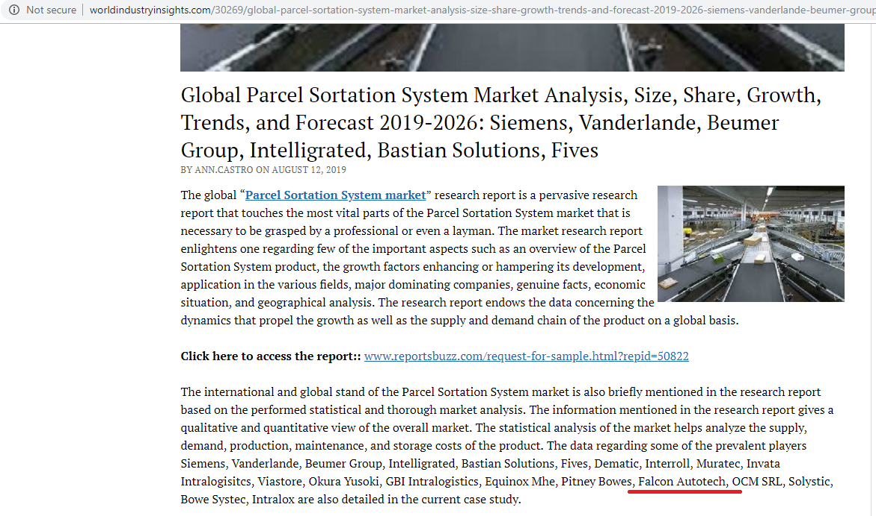
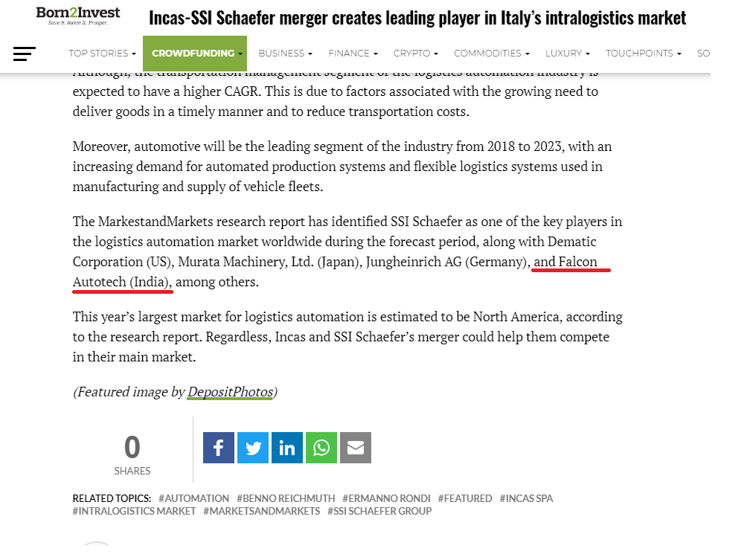
- Only company to be able to offer a Fully Integrated AMS.

Reference projects
Falcon has a strong legacy in Warehousing Automation solutions and references-

- Expertise in Piece Picking and Handling, Case Picking and Handling & Parcel Handling
- Lifecycle services (maintenance, spares supply chain, support).
- Full in-house expertise (Hardware/Software).
- Turn-key tailored solutions.
The references list presented below focusing on Sortation Solution –

Project 1- (CEP Client, UK)
This Solution is designed to handle a volume of 7200 parcels per hour. The system is equipped with three infeed conveyors integrated with automatic label applicator before parcels enter the sortation system. The parcels are sorted using Falcon's Loop Cross Belt Sorter equipped with automatic barcode scanning, dimensioning, weighing and image capture capabilities. The sorter is installed on the mezzanine floor and sorts directly to 58 end destinations.
Solution Specifications –
- Throughput: 7200 PPH
- End Destinations: 58 Nos
Key Technology Modules –
- Powered Belt Conveyors.
- Automatic Induct Lines.
- Automatic Barcode Scanner with Image Capture.
- Automatic Weight & Volume Measurement System.
- Loop Cross Belt Sorter.
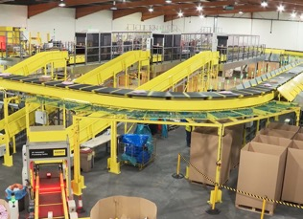
- WCS Software System.
Site Picture –

Project 2- (CEP Client, Riyadh)
In 2019, customer selected Falcon Autotech as a preferred supplier for its airport hub to supply linear cross belt sorter for processing of parcels arriving via Air from different states and countries to distribute them locally. The customer chose Falcon Autotech based on its strong track record of success in providing intralogistics automation solutions, optimized design, software integration capabilities and life cycle support services.
Solution Specifications –
- Throughput: 4800 PPH
- End Destinations: 52 Nos
Key Technology Modules –
- Powered Belt Conveyors.
- Automatic Induct Lines.
- Automatic Barcode Scanner with Image Capture.
- Automatic Weight & Volume Measurement System.
- ARB Conveyor.
- Automatic Label Applicators.
- Linear Cross Belt Sorter.
- Specialized Chutes for Gentle Parcel handling.
- FOCR Engine.
- WCS Software System.
Site Picture –
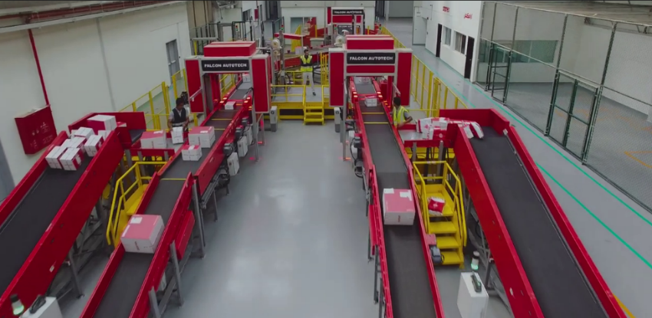

Project 6- (Client – Courier Express Parcel, Dubai & Jeddah)
This Solution is designed to handle the bulk volumes through Launchpads and induct them into Falcon's Linear Arm Sorter. This system is designed for a throughput of 3000 parcels per hour equipped with automatic barcode scanning, dimensioning, weighing and image capture capabilities to into a total of 480 end destinations with a combination of primary and secondary sortation system. The secondary sortation is achieved by integrating put to light system.
Solution Specifications –
- Throughput: 3000 PPH
- End Destinations: 480 Nos
Key Technology Modules –
- Powered Belt Conveyors.
- Linear arm sorter.
- Automatic Barcode Scanner.
- Automatic Weight & Volume Measurement System.
- WCS Software System.
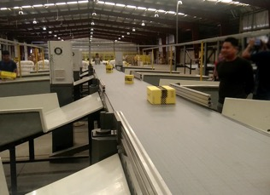
Site Picture –

Project 4- (CEP Client, Sydney)
Solution is designed for handling a throughput of 16,000 parcels per hour with the help of Falcon’s Loop Cross Belt Sorter. The system consists of 2 feeding zones with a total of 10 feedlines. Sorter design enables the van drivers to directly drop the parcels at the dock doors. It has a total of 369 end destinations that are achieved with a combination of direct drops and PTLs. System is integrated with 5 side automatic barcode scanning, weight and volume measurement and automatic detection of oversize and overweight parcels.
Solution Specifications –
- Throughput: 16000 PPH
- End Destinations: 369 Nos
Key Technology Modules –
- Powered Belt Conveyors.
- 2 Induct zone.
- 5 side Automatic Barcode Scanner.
- Automatic Weight & Volume Measurement System.
- Automatic detection of oversize parcel.
- Loop Cross Belt Sorter.
- WCS Software System.
Site Picture –
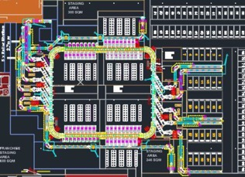

Project 3- (Client – E-Commerce, India)
Use Case – Destination Sorting of Packed Parcels.
In 2019, Client was looking for a potential automation partner for design and development of a new automated sortation system for B2C parcels. The system should be able to provide maximum uptime with reduced dependency on skilled manpower, and space optimization.
The customer chose Falcon Autotech based on its unique design which could cater to all their pain points, capability of seamless integration with WMS and life cycle support services.
Solution Specifications –
- Throughput: 27,600 PPH
- End Destinations: 410 Direct Outputs
- Building Size: 200,000 Sq Ft
Key Technology Modules –
- Bulk Infeed Conveyors.
- ARB based Volume Distribution System
- Integrated Presort System.
- Irregular Ejection System.
- Automatic Induct Lines.
- Automatic Barcode Scanner with Image Capture.
- Automatic Weight & Volume Measurement System.
- Loop Cross Belt Sorter.
- Smart Sliding Chutes for Direct bagging and Cage Sorting.
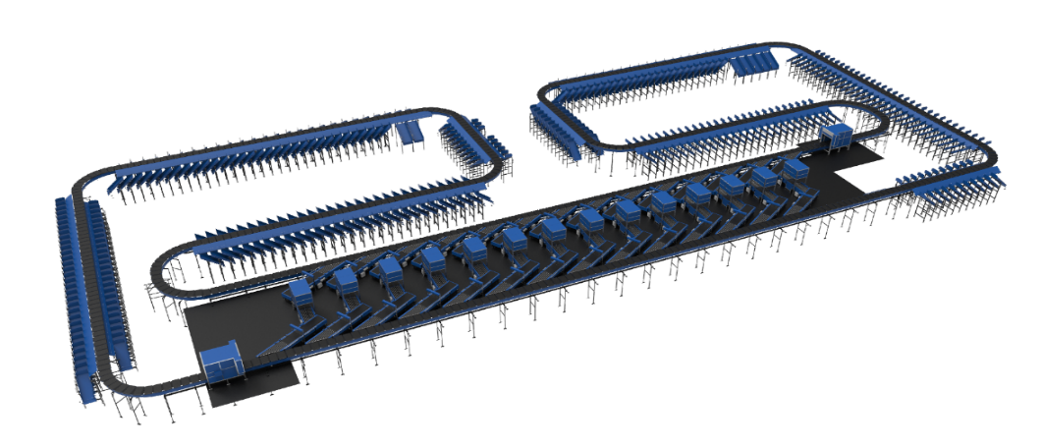
- Bag take out system
- WCS Software System.

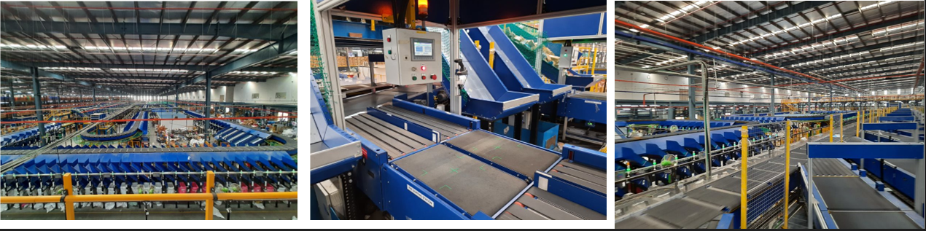

Project 5- (Ecommerce Client, India)
Use Case - Destination Sorting of Packed Shipments
Solution Specifications –
- Throughput: 24,000 PPH
- End Destinations: 110
- Building Size: 200,000 Sq. Ft
Key Technology Modules - Loop Cross Belt Sorter with a cell size of 900 x 500 mm

Layout and Site Pictures -

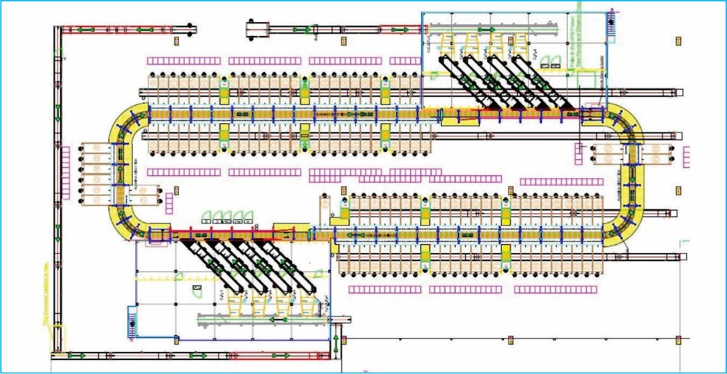

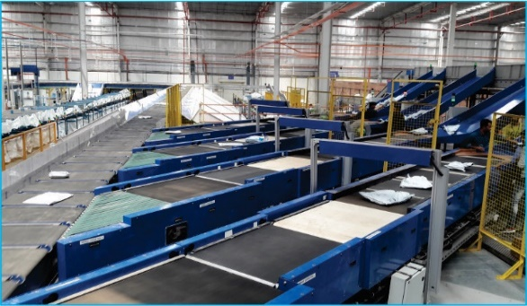
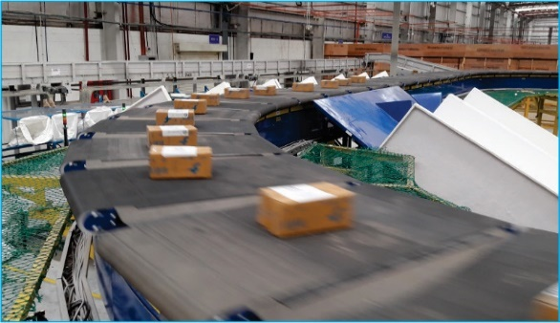
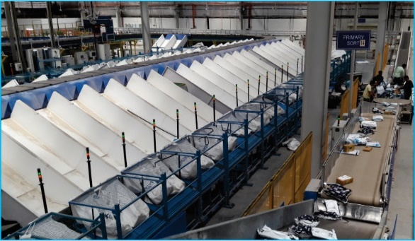

Layout & Pictures_ Project 1

Project 7- (E-commerce, India)
Solution is designed to handle the parcels Inbound and Outbound for packaging and sorting. Types of conveyors have used in this solution are as follows :
- Belt Conveyor
- Roller Conveyor
- Goose Neck Inclined

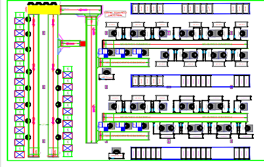

Handled Parcel Spectrumions Minimum Maximum

Product size Conveyable on the entire system.

Max Length | mm | 400
Max Width | mm | 400
Max Height | mm | 400
Max Weight | Kg | 5
Min length | mm | 150
Min Width | mm | 150
Min Height | mm | 10
Min Weight | gm | 100

Parcels/Totes to be loaded on Conveyor/Sorter shall have the following characteristics:

- Centre of Gravity of items must not move during conveyance or sorting.
- Item must not have magnetic content; otherwise behaviour of parcel cannot be guaranteed.
- Liquid or fragile material, to avoid breaking, spillage or leakage, such as wine bottles, metal cans of paint are designated as non- conveyable items.
- Parcels shall be perfectly and safely packaged: protrusion or open surfaces are not allowed.
- Plastic ropes shall be perfectly adherent to the surface of the package.
- All items with the risk of being damaged during the transport on an automatic conveying/sorting system or damaging the system. They must be robust enough to avoid disintegration of container material and loose of contents in the conveying/sorting process.
- Item packaging shall have enough grip to be handled on the belts during the acceleration and
referencing phases.
- Items shall not have slippery surfaces and must be able to withstand acceleration of the items on the belt during the start-stop phases (accelerations up to 0.5 g shall be assured without any sliding or tumbling of the items on the belt conveyor).
- The parcels must have at least one flat and regular surface providing enough stability during conveyance.
- All shapes are permitted except spherical, cylindrical, or alike unstable items & shapes.
- All usual packaging materials are permitted (including paper, carton, plastics, plastic foil, rope, tape, textile, and wood)

Parcel not loadable on the system
All products that are not within the range as described here, are considered non- conveyable products, and must be taken out of the main sorter flow by the operators.

- Unstable items with a risk to roll or tumble on the sorting system, such as spherical or cylindrical items
- Items that have a spherical or cylindrical shape.
- Items that are packed in material that can damage the conveyors or the sorter.
- Items that have sharp points (e.g. Nails) or sharp edges, that can damage the conveyors or the sorter.
- Fragile parcels with contents not sufficiently secured
- Items that have been classified as dangerous are designated.
- Wet items are designated.
- Items with anti-slip treatment.
- Items with protruding parts.
- Items with sharp edges.
- Inadequately packed items that could be damaged during automatic transportation.
- Electrostatically loaded items.
- Loose parts on loads and load carriers, such as adhesive tape, stickers, slips of paper, straps, wrap foil etc. are designated as non- conveyable items.

Types of Products
Parcel Type | Description
Cartons/Polys | Max: L 400 mm X W 400 mm X H 400mm  Min: L 1500mm X W 150mm X H 10mm

Proposed System Description

Objective
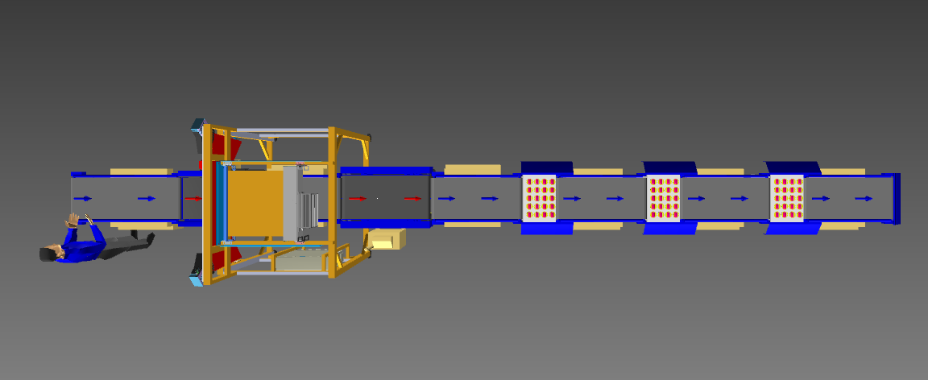
The purpose of this proposal is to present the design, manufacturing, installation, commissioning, testing and acceptance testing of the complete SWEDI sorter system to handle Parcel as per specifications shared by MSC-Q.

Summary of the System
- Infeed: Manual loading of parcel is done by Operator on loading conveyor.

- Scanning, Weighing & VMS: After loading, Weight measurement, Volume measurement & Barcode scanning is done automatically.

- Outbound Sorter: Parcel now travel further & get sorted in either chute/totes/bins (in client scope) according to MSC-Q’s logic with the help of SWEDI diverter unit.

- Sort Fail: Flange is placed at end of the line where sort fail bin can be placed to collect the parcel.

Main benefits of the proposed solution
The proposed solution has the following advantages:
- High operational throughput
- Maximized sorting capacity throughout at dispatch sorter to meet the requirement.
- Low occupancy of floor space in the building
- FALCON’s system can adapt with changing business requirements by adjusting its speed to match the operational throughput requirement, thereby leading to Power Savings and reduced system Wear & Tear

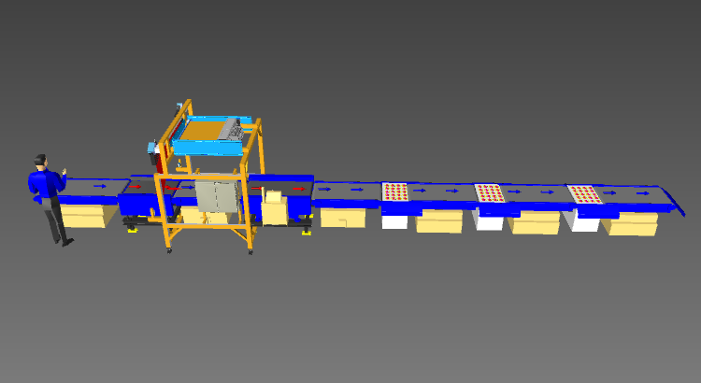
Layout View
5
5
3
4
2
1
Legend
1 – Loading Conveyor
2 – Buffer conveyor
3 – Scanning Tunnel
4 – Weighing conveyor
5 – SWEDI diverter units

Proposed System Capacity

System Capacity
Activity | Parcel per day
SWEDI Diverter | 2000

System description

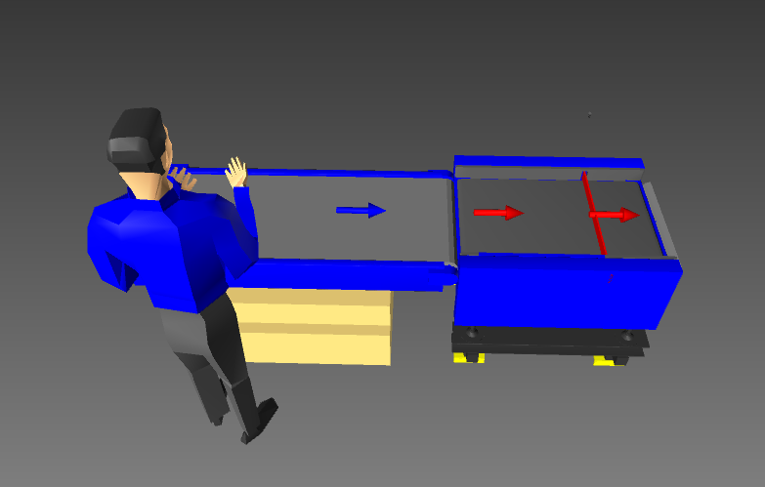
Loading conveyor and Buffer
2
1

Legend
1 – Loading Conveyor
2 – Buffer Conveyor

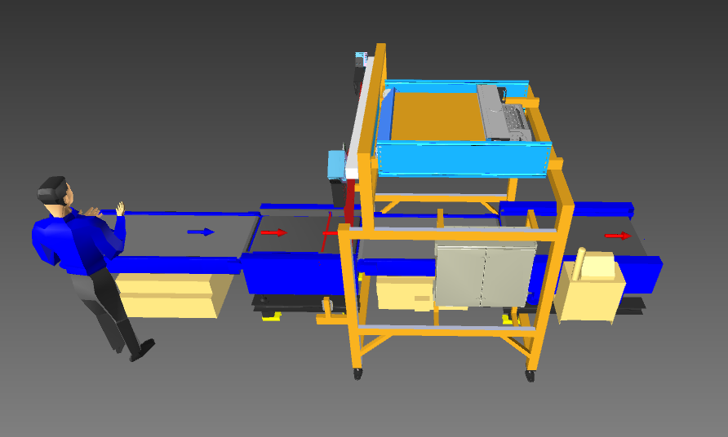
Scanning & Weighing
2
1

Legend
1 – Barcode scanning & VMS
2 – Weighing Conveyor

Outbound Sorting
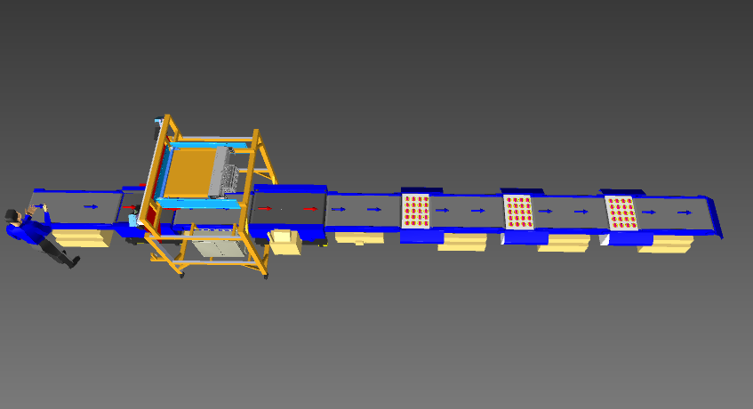
3
2
1
1
1
2
Legend
1 – SWEDI diverter
2 – Collection bin placement area
3 – Sort fail bin placement area

System Components

PVC Belt Conveyor
Falcon’s Belt Conveyors are modular & robust in design. MS profile is used to build conveyor frame.
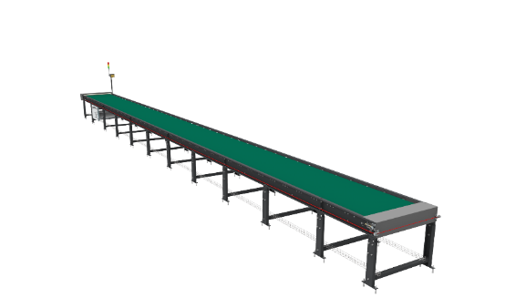
Some Salient Features of Falcon’s Belt conveyor:
- Low Noise
- Maximum uptime.
- Minimal maintenance
- High safety standards.
- Fastest ROI.

Specification | UOM | Remark
Manufacturer Name | Name | Falcon Autotech
Material of Roller | Type | MS Rollers with Zinc Plating
MOC of Belt | Type | PVC
Belt Thickness | mm | 3
Belt Finish | Type | Matt Finish
Belt width | mm | 600
Belt Joint Type | Type | Vulcanized, Endless Belts
Belt Make/Model No. | Make | FORBO/DERCO
Chassis | mm | MS, 3mm Thick, Powder Coated-75 Microns
Idler Roller Pitch on running side (Top) | mm | 480
Idler Roller Pitch on return side (Bottom) | mm | 1200
Idler Roller Specs | Spec | Dia.50.8, shaft-12 mm, bearing-6301
End Rollers | Spec | Dia 81.2 x 2.85 Thick, 30mm Shaft Dia, & Bearing Size-UCFH206D1, MOC-EN9, Zinc Plated -25 microns
Drive Rollers | Spec | OUTER Dia 178 PIPE Dia 168x5 Thick, 40mm Shaft Dia, & Bearing Size-UCF208D1, MOC(SHAFT)-EN9, NEOPRENE RUBBER COATING
Tensioning Rollers | Spec | Dia 81.2 x 2.85 Thick, 25mm Shaft Dia, & Bearing Size-UCT205D1, MOC-MS, Zinc Plated -25 microns
Type of Drive | Type | Rubberized
Angle of wrap/Contact - Belt with Drive pulley | Deg | >180 deg
Motor Shaft | MOC | EN9 Shaft material,
Conveyor Under guarding | Spec | MOC-MS, 0.8 to 1mm thickness, Steel Stiffeners at every 600mm to avoid the sagging due to self-weight
Load capacity per unit length of Conveyor | kg/m | 50
Drive Power Rating | kW | Motor Rating depends on Length of the Conveyor
Type of Motor | Type | AC Geared Motor
Type of Drive System | Type | Direct Shaft Mounted Motor/ Flange Mounted
Type of Drive | Type | Chain drive/Torque Arm type
Gear Motor | make | Sew/Nord
Drive | make | Lenze/Siemens/Omron/Allen Bradly
Insulation Class | Type | Yes
Conveyor Speed | m/s | Variable speed to meet TPH requirements
Type of Mounts | Type | Fixed Heights Legs with Grouting Provisions

Swivel Wheel Sorting Unit - Falcon
Falcon’s Swivel wheel divert is used in system for the smooth transfer of products.
Some Salient Features of Swivel Wheel Divert:
- Low Noise
- Maximum uptime.
- Electric based rotation of wheels.
- Minimal maintenance
- High safety standards.
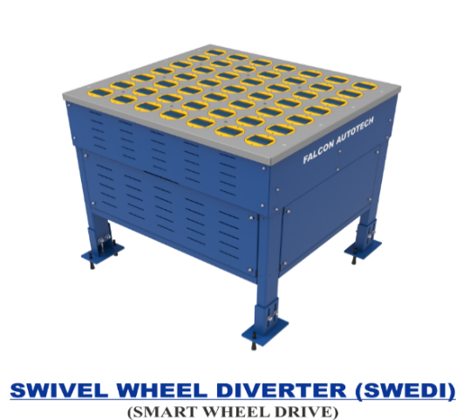

Specification | UOM | Remark
Manufacturer Name | Name | Falcon Autotech
Type - Equipment | Type | Merge/Sorting
Type - Operation | Type | Sorting
Mechanism for Swivel | Type | Electric servo motor
Roller drive | kW | Powered smart wheel
Roller pitch (L x W) | Type | 110 x 120
No. of divert sections | Yes/No | 1 or 2
Type of Mounts | Type | Fixed Heights Legs with Grouting Provisions

Top side Barcode Scanners with Volume Measurement System
System is integrated with automated inline cameras for multi side scanning with high accuracy.
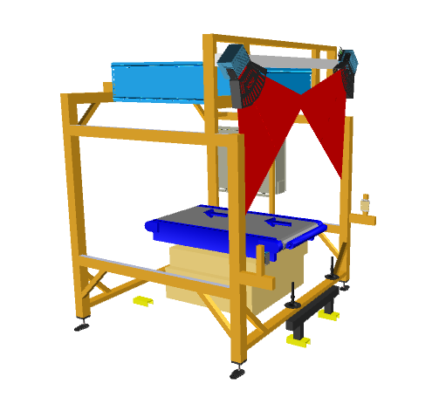
SICK VMS 5200 for Dimensioning of Parcels.

Buffer Conveyor
System is integrated with a buffer conveyor to maintain required pitch among two consecutive parcel before entering ICR tunnel for scanning & VMS.
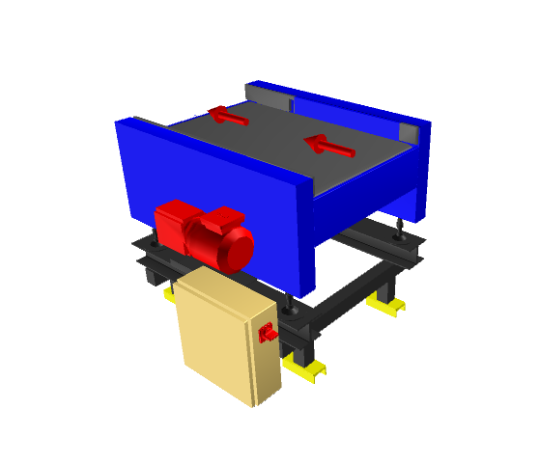

Proposed System Technical Details/BOM

Mechanical Equipment
S.no. | Qty. | Description | Value
1 | 1 | Conveyors  04 X Powered belt conveyor (Outfeed) ~ 4.8 m  01 X Scanning conveyor  01 X Buffer conveyor  01 X Weighing conveyor | Width  ~ 610 mm
2 | 1 | Diverter  03 X SWEDI units | Included
3 | 1 | Destination  07 X Transfer flange | Included
4 | 1 | Scanning Tunnel  01 X top Side barcode scanning  01 x Volume Measurement System | Included
5 | 1 | Standard Falcon Safety Equipment | Included

Electrical Equipment
Electricals
1 | 1 | Consists of  Main Control Panel  Network Switches  Field Cabling | Included

Control System
Components
2 | 1 | Consists of  Siemen’s PLC based Control System | 1 Nos.  As per requirement

Falcon’s WCS CONTROLIT
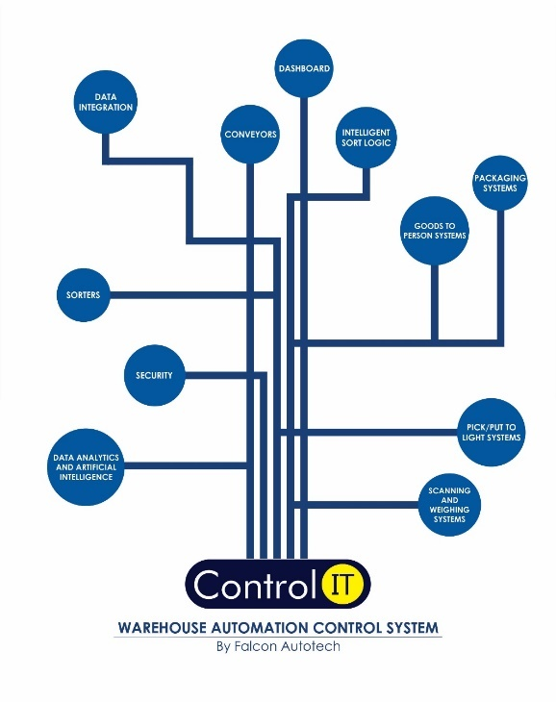
Key Values
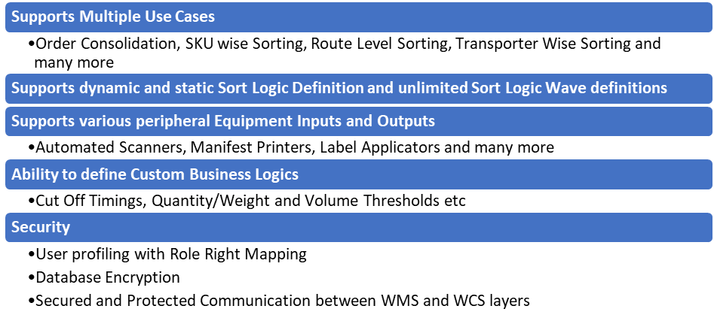Supported Protocols
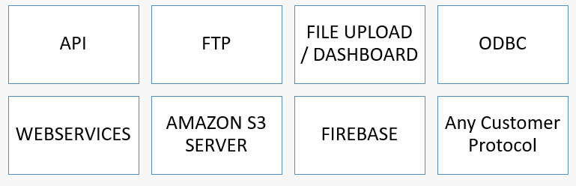

Key Component Makes
Component | Make
PLC & RIO | Siemens
VFD | Siemens/Omron/Lenze/AB
Ethernet switch | Siemens/Phoenix Contact
SMPS | Omron/Selec/Meanwell
Slim relays | Phoenix contact
Terminals | Wago
Tower lamp + Hooter | Leuze
Switchgear | Schneider
Geared Motors | SEW
MDR | Pulse
Volume Scanner | Cognex/Sick
Cameras | Cognex/Sick
Weighing Scale | Mettler Toledo/Bizerba

Safety

Push Buttons

Push Button
Emergency Push Buttons and Pull Cord Switches will be provided at all the points of human interaction on the system as per Falcon Standard design parameters.

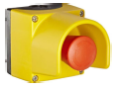

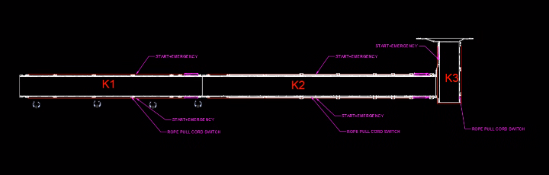

Program Management
For this program, proposed approach covers the following aspects:
- Creation and monitoring of the project plan.
- Communication with MSC-Q
- Scheduling of the resource management.
- Management of the risks and opportunities.
- Management of the list of anomalies or reservations.

Commercial Terms

Price Sheet
S.no. | Description | USD
1 | Swivel Wheel Sorter | $ 1,20,378
2 | Conveyor Automation | $ 11,500
3 | Destination chutes | $ 289
5 | Toolkit | $ 462
6 | Control Software and IT Integration | $ 7,692
7 | Project Management | $ 3,674
8 | Packaging & Forwarding | $ 6,631
TOTAL |  | $ 1,50,626

The Total Price is to be understood.

- Freight- Exclusive
- Number of container required- 01 X 40 ft.
- Freight charges shall be extra at actual.
- Including Packing and Forwarding
- Duty unpaid
- Installation and Commissioning: Exclusive
- Required Man-days (Shared below)
- Price is valid for 60 days from the date of proposal.

Our Price does not include taxes, and duties, import duties, charges, fees, taxes etc. charged by authorities outside India for deliveries and services. Same shall be borne & paid by client itself.

*Material Unloading & Laydown area is in customer scope.

S.No | Particulars | Man-Days on 10 Hrs. Basis | Remarks
2 | Mech. Engineer | 18 | Duration of Project : 15 Days  Considering MHE (Hydra/Forklift/HOPT) is in Customer Scope
3 | Elect. Engineer | 18
4 | Mech. Technician (Contractor) | 36
5 | Elect. Technician (Contractor) | 12
6 | Helper (Contractor) | 54

Note: Mechanical & Electrical Engineer will fly from India & related expense will be charged extra.

Payment Terms
50% Advance along with PO & balance 50% along with taxes before dispatch.

Delivery time line
Currently under review, will be confirmed Monday 22 May 2023 with final proposal.

Warranty Period
Falcons offered System comes with a standard warranty of 1 year (Starts from the date of beneficiary use) and post completion of warranty, customer can opt for Extended warranty. Warranty covers the following support:
- 24 X 7 Telephonic, Email and Remote Service Support when required
- Regular Software updates and Bug Fixes.
- Supply of Mechanical and Electrical components in case of failure (excluding damages as mentioned in Exclusion Clause)
The warranty does not apply to replacement or repair of:
- Normal wear and tear.
- Consumables.
- Faulty articles continued:
  - Failure to comply with the manufacturer's recommendations (logistics documentation, Technical Information Note, retrofit document) and the rules of the trade.
  - Negligence or abnormal use of equipment.
  - Anomalies produced by an environment of use, storage or transport that does not comply with the specifications or recommendations of Falcon: packaging, temperature, hygrometry, sector, insulation, etc.
  - A defect due to a cause external to the supplies and services of Falcon.
- Equipment other than that supplied by Falcon.
- Items that can be repaired exclusively by Falcon that have been repaired or attempted repairs other than those carried out by Falcon.
- Items that fail due to normal wear and tear of one or more of its components or whose tamper-evident seals (varnish, strip, etc.) have been broken or whose serial numbers have been removed or modified.
- Items damaged during transport to Falcon due to the use of unsuitable packaging.

Exclusions
The scope of supply includes all parts which are defined in the Supplier’s quotation.

All other parts which are not defined in the Supplier’s quotation do not belong to the Supplier’s scope of supply and are excluded. The following parts are also excluded:

- Steel work is not specified.
- Chutes/Bins/totes
- Operator platform
- Server PC
- Existing mezzanine to take conveyor system loading
- Any disassembly of current equipment already installed on site
- Construction Power
- Building infrastructure; building structure, doors, fire exits, levelling devices, building extinguisher and fire alarm system, building heating and lighting system.
- Electrical power supply and wiring to the main control cabinets
- UPS for Controls and Drives
- Electrical Power for Installation
- Network Cabling up to the Main Server Rack
- Intermediate wiring to parts which are to be supplied by the Purchaser/others
- Emergency/Uninterruptable power supply
- Fire-alarm and fire protection devices
- Traffic and route markings
- Laydown Area
- Ram protection devices
- Cat walks, bridges, maintenance aisles and platforms- If not specified
- Assembly tools like forklifts and hoisting machines
- All kind of network incl. Local Area Network (LAN/WLAN), exceeding the scope described in Scope of Supply
- Any Kind of Civil work
- Any adjustment of the Supplier’s scope of supply to local rules and regulations
- X-Ray machines
- Roller cages/ Pallets
- Simulation and 3D animation of the sorter system
- Interface with other equipment not specified in this offer.
- Provision of facilities for the control room (furniture, air conditioning, heating, etc.).
- The supply and installation of fencing around the different corridors.
- Any item specifically indicated as not forming part of the subject matter of the Seller's supply in the offer documentation.

